**Telephone: 01522 703 912**

**Email: burials@saxilbyparishcouncil.gov.uk**

**Website: www.saxilbyparishcouncil.gov.uk**

St. Andrews Community Centre

William Street

Saxilby

Lincoln

LN1 2LP

**Saxilby with Ingleby**

**Parish Council**

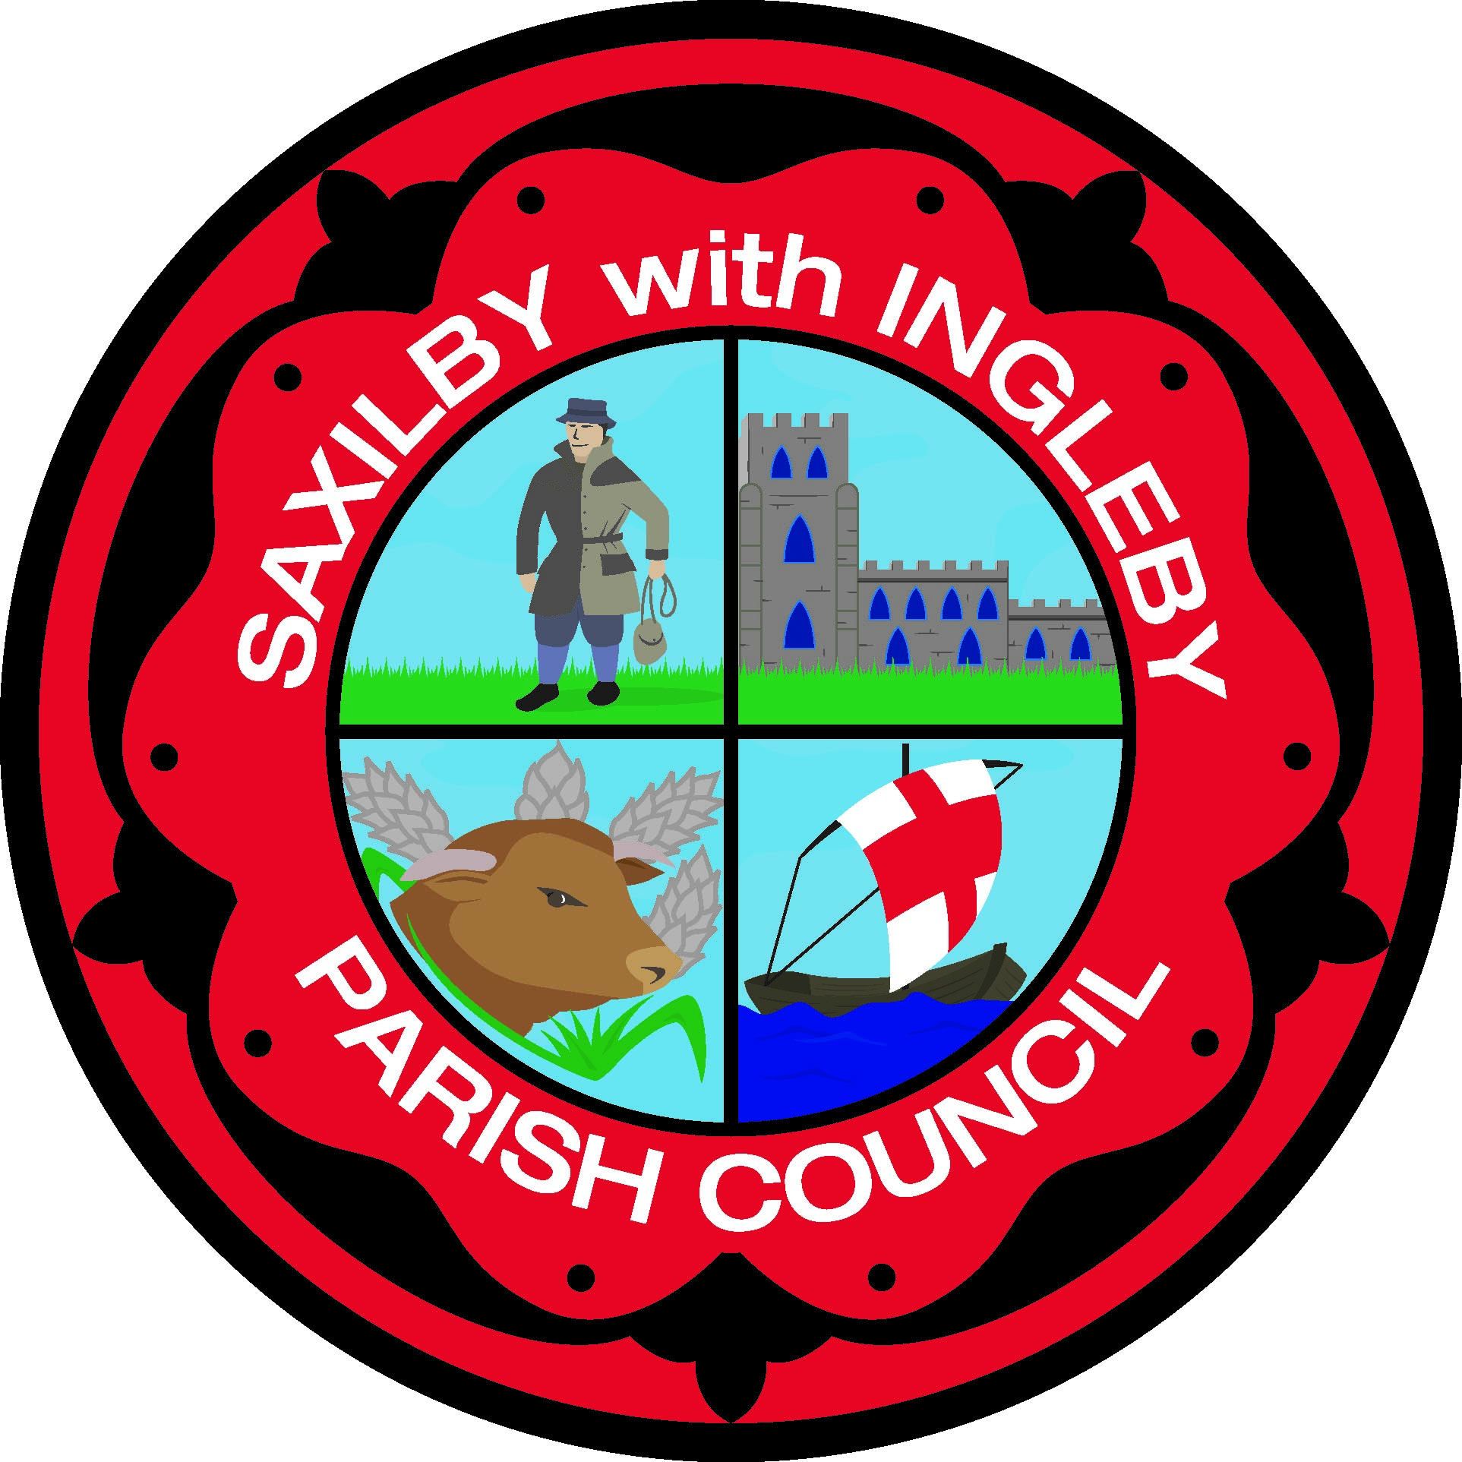

**Saxilby Cemetery**

**Reservation – Pre-Purchased Plot/s**

Please complete one form per reserved lot request

Applicant Full Name: ………………………………………………………………………

Postal Address: ………………………………………………………………………

………………………………………………………………………

Town: ……………………………………….

Post Code: ……………………………………….

Contact Number: …………………….. (h) ……………………….. (m)

E-Mail address: …………………………………………………….

**Type of Plot required (delete one): Lawn Ashes**

**Size of Plot required (delete one): Single Side by Side\***

*Please note that we no longer permit double-depth lawn plots, but side-by-side lawn plots can be purchased.

This Plot is for use by the following nominated person(s)

Name: …………………………………………………………..

Date of birth: ………………………………

If you have purchased a Side by side Plot then complete the part below: -

Name: …………………………………………………………..

Date of birth: ………………………………



I (full name) ……………………………………… make application to the Saxilby with Ingleby Parish Council to reserve a cemetery plot.

I understand that the plot must be paid for in full before Saxilby with Ingleby Parish Council will uphold the reservation.

I understand that the fee payable for the plot does not include the interment.

I acknowledge that the above named persons will be eligible for interment in the plot reserved by the applicant.

Signed: ……………………………………………..

Date: ……………………………..

NOTES:

1. If you reside outside of Saxilby with Ingleby Parish an additional levy of 100% is added to all costs.
2. Where the Exclusive Rights of a grave or cremation plot is purchased, it gives the owner the right to determine future interments within the grave and to place a memorial upon the grave.
3. At a later date, it is often the case that the owner of the Exclusive Rights is interred within that grave. No further burials can be made in that grave unless the Exclusive Rights are formally transferred to another person, and assuming there is sufficient space.
4. The Exclusive Rights can only be formally transferred to another individual, following a strict legal process.
5. Please see the current Burial Ground Regulations for restrictions relating to memorials erected on graves.

Please send bacs payment to:

Saxilby with Ingleby parish Council

Account no: 65341416 Sort Code: 08-92-99

Please use Surname as the reference or invoice number if known.