
St Andrew’s Community Centre, Saxilby
Booking Form V6
Long Term Hirers

Date of Hire From/To:
 | □ All year □ Term time only

Purpose of Hire:

Hirer’s Name:

Hirer’s Address with Postcode:

E-Mail:
Daytime Contact: |  | Evening Contact:

Room Required:
□ Function Room □ Youth Club Room □ Meeting Room
Hire Start Time:  Including set up time |  | Hire Finish Time:  Including clearing away
Session Start for clasess |  | Finish:
Other Services: Please specify what furniture you require.

How many people do you expect to attend:
Will you be using the boiler and drinkware:
Do you play any music.
Total Cost per session: including set up and clearing away. |  |  | £
I have included a copy of my Public Liability Insurance □
I have included a copy of my Risk Assessments □

Hire Agreement
- Use of the Centre
Use of the Community Centre is subject to the following rules and in the case of hirers, to certain standard conditions incorporated in the hiring agreement.

- Hire fees (From 1 April 2025)
For hire fees, please see the Fees and Charges document available online at https://saxilby-ingleby.parish.lincolnshire.gov.uk/parish-information/community-centre

Regular hirers should have their own indemnity insurance and will be required to produce evidence of this on an annual basis.

- Equal Opportunities and Data Protection
The Community Centre shall be open to all members of the community in compliance with the provisions of the Equality Act 2010. Information you give us about yourself will be held on computer or manual record, which you have a right to see and check. Information may be shared with organisations we work with to provide services to you. Information may also be used in connection with the prevention and detection of crime and fraud. Our obligations under the Data Protection Act 1998 are explained in our Data Protection Policy which is available on our website. Hirers and users of the Centre must also comply with the Council’s Sexual Harassment Policy, available on our website.

- Applying to use the Centre.
- Application for use of the Centre shall be made to the Parish Office.
- The right to refuse any application for the use of the Centre facilities is reserved by the Council, or the Clerk(s).
- All arrangements for the use of the Centre facilities are subject to the Council reserving the right to cancel bookings when the premises are required for use as by the Council or are rendered unfit for the intended purpose.
- Local groups shall normally have priority use of the facilities but all arrangements to hire facilities made from outside bodies will be honoured except as provided for in (c) above.

- Hours of Opening
Facilities at the Community Centre are normally available for use between the hours of 9.00am-10.00pm.
In exceptional cases these hours may be extended on application to the Parish Office.
The Community Centre is closed on bank holidays and so there will be no regular room hire available on these dates.

- Maximum Capacity
The Centre has a maximum capacity of 120 per floor and on no account shall these figures be exceeded.

- Safety Requirements
All conditions attached to the granting of the Centre’s Premises Licence shall be strictly observed. Nothing shall be done to endanger the users of the building and the policies of insurance relating to it and its contents. In particular:
- Obstructions must not be placed in the gangways or exits, or in front of the emergency exits which must be immediately available for free public egress.
- The emergency lighting supply must be turned on during the whole time the premises are occupied and must illuminate all exit signs and routes.
- Fire fighting equipment shall be kept in its proper place and only used for its intended purpose.
- The fire brigade shall be called to any outbreak of fire.
- Performances involving danger to the public shall not be held.
- Highly flammable substances shall not be brought into, or used in, any part of the building.
- No unauthorised heating appliances shall be used on the premises.
- The first aid box shall be readily available to all users of the premises: located in the bar kitchen on the ground floor, function room and the youth club room. Any items used should be reported to the Parish Office.
- All electrical equipment brought onto the premises shall comply with the current Electricity at Work Regulations. Each item must be Portable Appliance Tested by a certified electrician.
- Smoke machines must not be used within the building due to the sensitivity of the fire alarm sensors.
- CCTV operates inside and outside of the premises for the purposes of the detection and prevention of crime.

- Supervision
The hirer or person in charge of the activity shall not be under 18 years of age and shall be on the premises for the entire period of hire or duration of the activity. When the premises or any part of them are used for the purpose of public entertainment, there shall be a minimum of two persons aged 18 or over on duty. Any event with children/young persons under the age of 17 requires an adult supervision ratio of 1:8 (1 adult over the age of 18 for every 8 children. For younger children additional adult supervision may be required.

- Storage
Permission must be obtained from the Clerk before goods or equipment are left/stored at the centre, including authorisation of overnight storage of goods/ equipment before a particular event.

- Loss of Property
The Council cannot accept responsibility for damage, loss or theft of Centre user’s property and effects.
If hirers bring their own equipment, it must be PAT tested.
Hirers would need to sign to confirm acknowledgement of their responsibilities.

- Car Parking
Car parking is available at the St Andrews Centre.

- Nuisance
- Litter shall not be left in, or about, the Centre premises.
- Hirers are responsible for ensuring that the noise level of their function is not such as to interfere with other activities within the building and does not cause inconvenience for the occupiers of nearby houses and property.

- Cleaning, Security and Care of Centre
All use of the Centre premises and facilities is subject to the hirers accepting responsibility for returning the furniture/equipment to its original position and for securing doors/windows of the premises as directed by staff. All hirers shall leave the premises and grounds in a clean and tidy condition. Any excess rubbish must be taken home and not left in the centre or their bins. Any food must be cleaned up (cleaning equipment is provided) Any damage must be reported to staff at the time or immediately after the session. The hirer is liable for any damage caused.

- Payment
Regular Hirers will be invoiced monthly, and invoices must be paid by the due date, otherwise we reserve the right to suspend the hire. The preferred payment method is by bank transfer. If bank transfer is not possible, arrangements with the Clerk to pay by cheque can be made.

If a payment made to the Centre, by a hirer, is subsequently declined causing us bank charges, the Council will seek reimbursement from the hirer concerned for the charge incurred.

Minimum of 48 hours’ notice is required if the bookings is to be cancelled. Otherwise, full payment will still be due.

- Additional Safety Measures
All hirers must read and be familiar with the Fire Safety Procedures. The use of candles (except on a cake) is not permitted. All hirers must accept responsibility for the safety of their guests and anyone attending their function. They must identify and assess any potential risk posed. For large events a written risk assessment must be completed, and a copy given to management.

Suitable Bouncy Castles are permitted in the Centre in the Youth Club Room but are not permitted in the Function Room. However, all hirers must accept responsibility for making sure they conform to the safety procedures laid down by the Bouncy Castle Hire Company as the Council cannot accept responsibility. Hirers must also ask to see from the Bouncy Castle Hire Company, a copy of their Public Liability Insurance and proof that the Bouncy Castles are maintained for safety on a regular basis. Copies must be given to management.

- Additional Hire Information

The St Andrews Community Centre is a Licensed Premises as designated under the Licensing Act 2003. We comply with all applicable objectives and laws. Any persons found to be in breach of the Licensing Act will be requested to leave the premises immediately. Any member of staff can request a person to leave the premises or refuse the sale of alcohol without giving reason. Failure to leave the premises when requested is a criminal offence under Section 143 of the Act. Hirers must also comply with the Council’s Alcohol Sale Policy, which can be viewed online here: https://saxilby-ingleby.parish.lincolnshire.gov.uk/downloads/file/1632/alcohol-sale-policy-v1-0-approved

- Room measurements:

Youth Room 2.72 M High 9.16m Wide 13.5 m long.
Function Room 9.14m Wide 15.3 m long
Meeting Room 3.7m wide 4.9 m long
Bar area 9.14 m wide 15.3 m long

Emergency Evacuation Plan
A General Emergency Evacuation Plan (GEEP) is a plan that highlights a buildings General layout, evacuation procedures and equipment used in an emergency. To enable visitors to St Andrews Community Centre with restricted mobility or those who may not be able to evacuate unaided to safely leave the building in the event of an emergency.

Our responsibility
St Andrews Community Centre has a legal responsibility to put measures in place for the safe evacuation of persons from its buildings, regardless of their usage. The building is equipped with the means to detect fire/smoke, for an alarm to be raised, and for the occupants to reach a place of final safety. If you feel that this document does not provide you with sufficient information or that you require further assistance, please inform a member of staff.
The building: St Andrews Community Centre is comprised of two floors. The second floor is accessible by using a lift or the central staircase. There are five emergency exits, two of which are on the first floor (see attached floor plan). It should be noted that all access to the building and means of horizontal evacuation above ground level require the use of steps. The building is equipped with the means to detect fire/smoke - for an alarm to be raised, both audible and visual, and for the occupants to reach a place of final safety.
Action required on hearing the Fire Alarm:
If able, you should leave the building immediately by the nearest fire exit (see attached floor plan) and report to assembly point A located in the carpark at the rear of the bowling green beside the Memorial Gates. If you are unable to evacuate the building unaided, please contact a member of staff who are trained in evacuation procedures.
Other recommendations:
Not all fire escapes are accessible by wheelchair and visitors to St Andrews Community Centre should familiarise themselves with the fire alarm signals and floor layout of the building. Floor plans and evacuation equipment locations have been provided with this document.

Equipment provided:
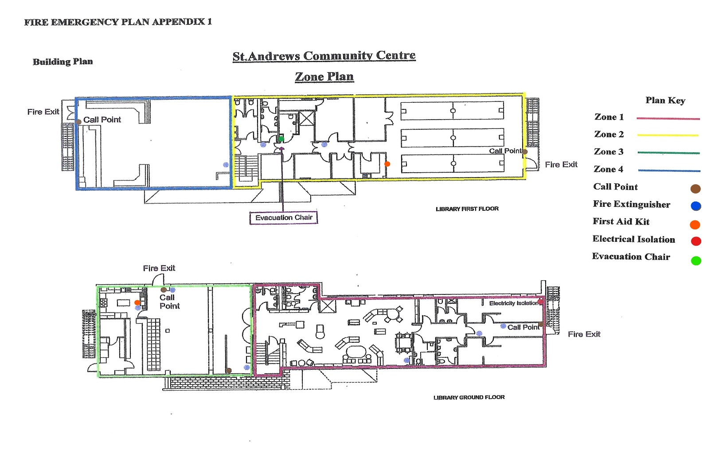
There are three disabled accessible fire exits on the ground floor. An evacuation chair/sledge is located on the first-floor corridor next to the disabled toilet. Centre staff are fully conversant in its usage.

Consent Form
Your privacy is important to us and we would like to communicate with you about the council and its activities. To do so we need your consent. You can find out more about how we use your data from our “Privacy Policy” which is available from our website www.saxilbyparishcouncil.gov.uk or from the Council Office, St Andrews Community Centre, William St, Saxilby, LN1 2LP.

You can withdraw or change your consent at any time by contacting the council office.
- We may contact you to keep you informed about what is going on in the Council‘s area or other local authority areas including news, events, meetings, clubs, groups and activities. These communications may also sometimes appear on our website, or in printed or electronic form (including social media).
- We may contact you about groups and activities you may be interested in participating in.
- We may use your name and photo in our newsletters, bulletins or on our website, or our social media accounts (for example our Facebook page or Twitter account).
I agree that the Council may process my personal information for providing information and to correspond with me. Please fill in your details below to confirm your consent. If you are aged 13 or under your parent or guardian should fill in their details below to confirm their consent.

Based on NALC, GDPR Toolkit Template 2018

DECLARATION AND CONSENT:
I have read and agree to comply with the Terms and Conditions of the Hire Agreement including the fees and give my consent for the council to communicate with me.
Name:
Signed:
Date:
Please return the completed signed form to:

assistant@saxilbyparishcouncil.co.uk

Parish Clerk, St Andrews Community Centre, William Street, Saxilby, LN1 2LP.
01522 702110

Payment by bank transfer is preferred:

Saxilby with Ingleby Parish Council
Account No: 65341416
Sort Code:089299

Please use your invoice number as your payment reference.

Last updated April 2025

