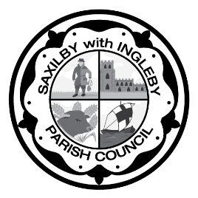
Saxilby Family Fun Day 2026: Sponsorship Confirmation Form
Saturday 22 August 2026 | 12pm – 5pm | Approx. 2,600 visitors
To confirm your interest in sponsoring Saxilby Family Fun Day 2026, please complete the form below and return to admin@saxilbyparishcouncil.gov.uk. We will then confirm availability of your chosen sponsorship package and arrange for an invoice to be sent to the email address provided.
Business/organisation name: | Click or tap here to enter text.
Contact name: | Click or tap here to enter text.
Email address: | Click or tap here to enter text.
Telephone number: | Click or tap here to enter text.
Preferred sponsorship package: | ☐ | Main event sponsor (£500)
Preferred sponsorship package: | ☐ | Event sponsor (£250)
Preferred sponsorship package: | ☐ | Community sponsor (£100)
Company name as you would like it to appear in publicity: | Click or tap here to enter text.
Will you require a pitch space at the event? | ☐ | Yes
Will you require a pitch space at the event? | ☐ | No
Will you be providing a banner for display at the event? | ☐ | Yes
Will you be providing a banner for display at the event? | ☐ | No
Banner/signage details: | Click or tap here to enter text.
About your business/organisation:  Please provide a short description of your business or organisation. This may be used for event announcements and promotional materials (eg. social media posts) | Click or tap here to enter text.
Website/social media links: | Click or tap here to enter text.

Logo submission: Please email a high-resolution version of your logo to admin@saxilbyparishcouncil.gov.uk

Agreement:
I confirm that I wish to sponsor Saxilby Family Fun Day 2026 and understand that sponsorship will be confirmed once payment has been received.
Name: | Click or tap here to enter text.
Signed: | Click or tap here to enter text.
Date: | Click or tap here to enter text.

